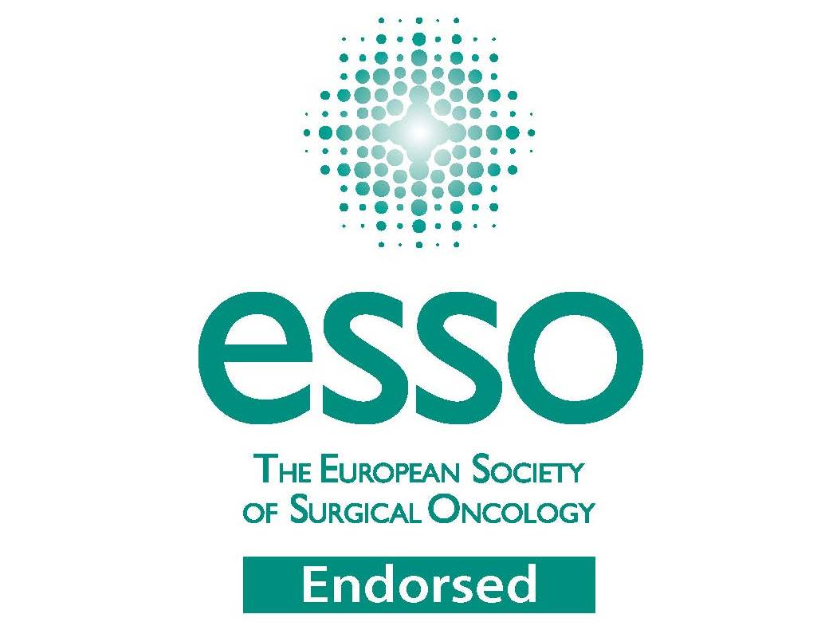
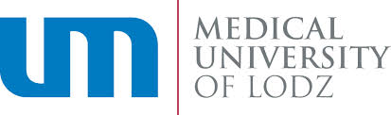

Breast surgery workshop- Cancer Centre, Medical University of Lodz, Poland, November 6-7, 2015
Paderewskiego 4
93-509 Lodz, Poland

Thursday, November 5, 2015
Hotel accommodation
Friday, November 6, 2015
8.00- welcome and introduction, pre-operative marking (Dept of Surgical Oncology, 1st floor)
Operating theatre A
8.45-10.15 – BCS-oncoplastic technique+SNB
10.30- 12.45- Nipple- sparing mastectomy and ADM & dermal sling based reconstruction
Operating theatre B
8.30-10.15- Fat transfer
10.30- Risk-reducing mastectomy BRCA 1 mutation
12.45-13.45- Lunch
14.00- 15.50 Lectures- conference room, ground floor
1. Breast asymmetry in breast cancer and congenital breast diseases- Dr Marek Budner, MD, PhD, Bad Saarow, Helios Klinikum, Germany
2. Breast cancer screening programmes- Prof. Rafal Matkowski, MD, PhD, Medical University of Wroclaw, Poland
3. Correction of aesthetic and functional sequelae in breast cancer surgery-Assistant Prof. Agnieszka Kolacinska, MD, PhD, Medical University of Lodz, Poland
4. BRA (Breast Reconstruction Awareness) Day- Dr Piotr Pluta, MD, PhD, Medical University of Lodz, Poland

19.00- Dinner
Saturday, November 7, 2015
8.00- pre-operative marking
8.45-11.45- LD flap
12.00-13.15- Delayed breast reconstruction- expander
13.30-14.00- discussion, closing remarks, certificates of attendance

Scientific committee:
Dr Marek Budner, MD, PhD, Bad Saarow, Helios Klinikum, Germany
Assistant Prof. Agnieszka Kolacinska, MD, PhD, Medical University of Lodz, Poland
Prof. Zbigniew Morawiec, MD, PhD, Cancer Centre, Lodz, Poland
Prof. Arkadiusz Jeziorski, MD, PhD, Medical University of Lodz, Poland
Prof. Rafal Matkowski, MD, PhD, Medical University of Wroclaw, Poland
Dr Pawel Basta, MD, PhD, Medical University of Cracow, Poland
Dr Artur Bocian, MD, PhD, Holycross Cancer Centre, Kielce, Poland
Dr Piotr Pluta, MD, PhD, Medical University of Lodz, Poland

